
Professor William Cartwright
William Cartwright is Professor of Cartography and Geographical Visualization in the School of Mathematical and Geospatial Sciences at RMIT University, Australia. He is a Vice-President of the International Cartographic Association and a National Councillor of the Mapping Sciences Institute, Australia. He is a member of the International Cartographic Association's Commission on Visualization and Virtual Environments and the Commission on Maps and the Internet. His major research interest is the application of multimedia to cartography and the exploration of different metaphorical approaches to the depiction of geographical information. He holds eight university qualifications - in the fields of cartography, engineering, education, media studies, information and communication technology and graphic design.

APPLYING DYNAMIC SPATIAL UPDATING IN A THEMATIC MAPPING ENVIRONMENT
Dr Lesley Arnold
Landgate, Western Australia
1 Midland Square, Midland, Western Australia, 6056
Tel: 08 9273 7201 / Fax: 08 9273 7674
Email: lesley.arnold@landgate.wa.gov.au
Professor Graeme Wright
Curtin University of Technology
GPO Box U1987, Perth, Western Australia, 6001
Tel: 08 9266 4800 / Fax: 08 9266 2682
Email: G.L.Wright@curtin.edu.au

Abstract
Spatial scientists, and in particular national mapping agencies, are continually faced with the high cost of updating spatial information. Traditional techniques are extremely resource intensive. Organisations must revise both geographic and cartographic databases in order to maintain standards of geometric accuracy for GIS analysis and the arrangement of data for the production of maps at various scales. This process is time consuming and prone to human error.
Research, undertaken at Curtin University of Technology in Western Australia has examined this spatial updating problem in the context of thematic map publishing. A Dynamic Spatial Updating (DSU) process has been developed to automatically revise thematic maps at a range of scales.
DSU is implemented in a database-sharing and spatial views environment. Spatial views (map views) are virtual windows to an underlying geographic database, where updates to the database are reflected dynamically in all derived spatial views.
This paper examines the DSU process and demonstrates, via case studies, that by integrating a scale-independent data model, interactive cartographic display transformations and cartographic validation mechanisms, an integrated approach to spatial data maintenance and product management can be achieved.
DSU is enabled by encoding cartographic processes, such that map representations persist as graphic visualisations in spatial views. This persistence mechanism acts as a pseudo rule-base for update-propagation. Each time a spatial view is accessed, data and updates are automatically retrieved and the cartographic representation methods persistent in the view are automatically reapplied. In addition, a cartographic validation process has been developed to identify spatial conflicts that may occur at the map level after multiple iterations of updates to the database.
This approach supports centralised data management principles. Cartographic representations are stored latently in spatial views without impact to the underlying data source, which means the database remains constant and thus supports multi-user views. More significantly, the approach meets the needs of data users, who require flexibility to produce customised geographic data products from a primary data source and, at the same time, real-time updates for sustainable product management.

Introduction
This research is concerned with non-standard thematic maps, such as road directories and tourist maps that are specialised in nature and purpose. These maps are often produced from purpose-built geographic databases, which are primarily designed for the production of application-specific maps (or series maps), such as topographic, hydrographic and geological maps. Complex cartographic processing is therefore required to customise the application-specific geographic data in order to produce diverse thematic map themes.
The data maintenance task confronting national mapping organisations is immense and current methodologies are extremely resource intensive. This is because constant changes in geographical reality require that both geographic and cartographic databases be revised in order to maintain both the standards of geometric accuracy relevant to GIS analysis and the arrangement of data for cartographic presentation to produce maps at various scales. This practise is resource intensive and expensive, because map revision must be performed individually for each product database. Update-propagation between geographic databases is often not possible because databases are commonly disconnected
The process of updating multiple data sets is logistically difficult because workflows are divided. Map products are usually updated individually and in isolation of the databases. Links between database objects and their cartographic equivalents, required for propagating updates, are not supported. Whilst this is often due to interoperability problems between the spatial information system and map publishing software, it is primarily due to the complex nature of the cartographic process.
Cartographic processing, in particular generalisation, is used to refine geographic information to a format that can be easily understood by the map user. It affects the choice of map features, their relative importance, symbolisation, geometric appearance and locational accuracy. Traditionally, this is why individual map products have been manipulated in isolation of the primary database - generalisation and product-specific edits are only required for cartographic presentation, whilst geometrically correct data are preserved for spatial analysis.
Cartographic processing complicates the spatial updating process making it difficult to implement automated procedures. Links between database representations and cartographic representations become fragmented because cartographically processed map features will often have different semantic interpretations and graphical representations to their database equivalent. Therefore, spatial updates performed in the databases are not consistent with updates required for cartographic representation.
An ideal solution is to combine geographic data management, cartographic processing and spatial information updating into one fully integrated system so that updates to the primary database can be automatically propagated to derived cartographic products. One way to achieve this is for closer links to be forged between software that manages and transforms spatial data and that which displays it.

CONTEMPORARY RESEARCH
Currently, the majority of research has focussed on map regeneration (Blanchfield and Grubb, 2000), database-driven cartography (Howard et al., 2000; Millar, 1998), incremental updating strategies (Langran, 1993; Cooper and Peled, 2001), update-propagation (Kilpelainen, 2000; Harrie and Hellstrom, 1999; Wijngaarden et al., 1997), schema integration (Uitermark, 2001; Devogele et al., 1997), data matching (Hampe et al., 2003; Badard, 1999), dynamic representation (Glover and Mackaness, 1999) and lineage metadata approaches (Lanter, 1993).
These contemporary techniques have proven application in the field of application-specific mapping, but fail to meet the needs of the map publishing community, which deals with non-standard thematic cartographic productions. This limitation stems from: (a) the inability to automate generalisation for non-standard automatic map production and thus spatial updating, (b) difficulties associated with managing multi-scale data and (c) problems with acquiring cartographic knowledge to formulate rules for non-standard automatic map production and update-propagation. For instance, in their examination of update-propagation techniques, researchers note extensive programming requirements (Kilpelainen, 2000), the need for comprehensive cartographic rule-bases (Wijngaarden et al., 1997) and the lack of cartographic knowledge for rule formulation (Timpf and Couclelis, 1997), as impediments to update-propagation.
This indicates that the update-propagation is not suited to non-standard thematic mapping environments, because a reasoning process would need to be implemented for each map product. Whilst some rules would possibly be reusable, the majority of cartographic representation behaviour, such as symbology, selection/elimination and displacement, is unique to each product, requiring individual implementation schemas.
Similar difficulties have also been encountered in the examination of database-driven cartography. Full automation is unlikely to be achieved to the satisfaction of cartographers for non-standard map publishing in the near future because the approach also relies on the implementation of a comprehensive rule-base. These rules are difficult to define in terms of the scale and theme variations required for non-standard mapping because there are an infinite number of possible cartographic representations. The cartographic process is too influenced by a cartographer’s experience and intuition, and possible knowledge of the area being mapped (Joao, 1998). A database-driven approach in a non-standard mapping environment will only be truly possible when rules can be implemented in a manner that mimics human thought processes and where customisation can be implemented by the user (and not the database administrator) in a flexible manner.
This research examines dynamic spatial updating in the context of interactive cartographic processing in order to circumvent the problems associated with creating generalised cartographic representations automatically. This is achieved by implementing cartographic behaviour at the map level using cartographic display transformations. This research also examines spatial updating in the context of a scale-independent database structure in order to overcome the difficulties of implementing update-propagation strategies to consistently manage multiple representations of geographic data. This is achieved by incorporating geographical meaning into the database knowledge structure. These fundamental DSU concepts are examined below.

Database-sharing and Spatial Views
A key element of database philosophy is data sharing and user views (or external views). The majority of GIS support various user requirements by allowing them to view the database in different ways. This is referred to as the concept of views (Worboys, 1995). A view is a flexible representation of a database and thus supports cohabitation of the database schema (Claramunt and Mainguenaud, 1996).
The database-sharing and spatial views approach stems from the dynamic representation model where maps are live views of the underlying database. The key difference however, is that cartographic representation is not driven by the database but rather from the map application interface. This means a rule-base is not necessary as cartographic processing is implemented using a set of cartographic tools at the map level. An example of this approach is the concept of VUEL (View Element) developed by (Bedard and Bernier, 2002) for web-mapping.
A spatial view is a live window to the underlying geographic database. This means that updates performed in the database are also available in user views. When a spatial view is accessed (read) from the database, the data (and updates) are written to user views using the application (viewing) software. Spatial updates to user views can therefore be considered as dynamic, as updates to the primary geographic database are propagated transparently to user views in real-time.

The Conceptual Research Model
There are five major components to the conceptual research model – geographic database design, map production process development, data management concepts, dynamic spatial updating strategies, and database and cartographic validation mechanisms. These are fundamental concepts that underpin spatial information management. In this research, these concepts are integrated in a way that enables dynamic spatial updating (DSU) of customised spatial views for map production and digital data products. The relationship of these components is presented in Figure 2 and described below.
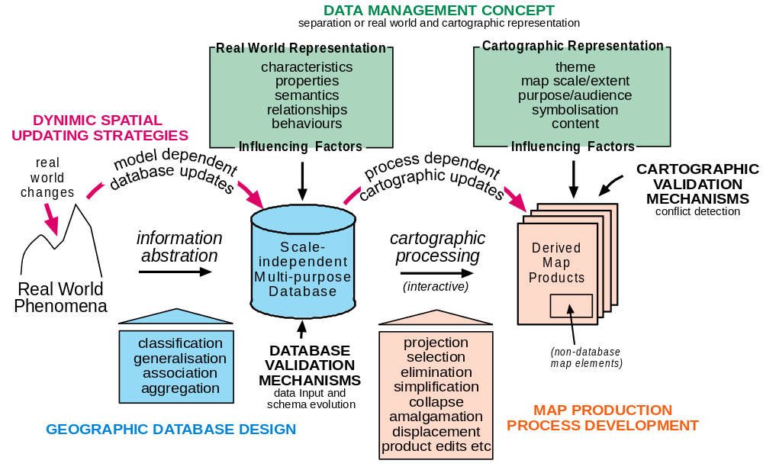
Figure 2 The Conceptual Framework for Dynamic Spatial Updating
Geographic Database Design
Fundamental to the DSU concept is a data model that incorporates the natural characteristics of geographic features and their real world behaviour. In this way it is possible to achieve a multi-purpose data source as geographic features are not defined according to specific cartographic representations. Instead, structural knowledge is based on real world referents. This means that the database can be organised and managed independent of any one specific purpose (Williams, 1990). A phenomenological approach to data structuring is considered the most appropriate approach, as real world semantics are the fundamental basis of all mapping applications at a broad range of scales. This approach provides a dynamic and flexible data model that takes into account various user requirements. This is essential as user requirements will often be functionally different from the purpose of the database schema.
A scale-independent data structure is required to support consistent data management. This is possible with the scale-independent approach as graphic features are recorded once at a high level of precision, which thus ensures consistency throughout the update process. Multiple representations are therefore not predefined in the database, but are generated at the spatial view (map) level using display transformations.
Map Production Process Development
Display transformations are algorithmic processes that support cohabitation of the database by multiple users. Each transformation is embedded with a persistence mechanism to enable DSU. This means that cartographic processes, executed by the user, will persist in the spatial view. Each time a spatial view is accessed, the primary spatial data are read and then written according the cartographic representation method (settings) defined by the user. Cartographic Representations (or Product-specific behaviour) of database objects are created without altering the underlying primary spatial data. This means that cartographic representations can be defined at the spatial view level under the control of the user rather than at the database level, which is the current norm.
Data Management Concepts
The overall data management concept is based on the separation of real-world and product-specific behaviour so that the database is not constrained to cartographic applications. This concept is fundamental to this research as real-world and product-specific behaviour need to be separated to achieve a versatile data management environment.
In this research, real-world behaviour is defined as the structural knowledge incorporated into the database to reflect objects as they occur in the natural environment. Product-specific behaviour is defined as the cartographic representation of an object generated by both structural and process knowledge (Arnold and Wright, 2005).
Dynamic Spatial Updating Strategies
The persistence of cartographic representation at the spatial view level is the key to enabling the DSU process. Spatial information read from the database will always be displayed according to the cartographic representation persisting in the view. The DSU process is successfully applied when the cartographic representation of an object does not have to be updated individually, but rather updated automatically as a consequence of the updates performed in the database.
In order to study the spatial updating process in terms of both geographic data management and product management, this research framework separates spatial updating into two distinct processes – those implemented at the database level (model-dependent updates) and those visualised at the cartographic level (process-dependent updates) (Figure 2).
Geographic information abstraction and cartographic processing govern the way in which spatial updating scenarios are performed. Essentially, the way geographic objects behave in response to operations when created, deleted and modified, either geometrically or semantically, depends on how objects are abstracted as a subset of reality and how cartographic processes are applied.
In essence, database updates constitute changes that reflect real world dynamic behaviour and are therefore dependent on how geographic entities are structured in the database; whilst cartographic updates constitute modifications to derived map products and are therefore dependent on the type of cartographic process implemented.
Database and Cartographic Validation Mechanisms
The validity of the DSU process relies on data input validation mechanisms as the integrity of the maps derived from the database is extremely reliant on the accuracy of the geographic database. This problem, whilst an issue in traditional map production, is more challenging in a database-sharing and spatial views environment as inaccurate updates to the database will have an immediate impact on the integrity of all the maps derived. However, there are a number of data modelling techniques that can be applied to reduce the risk of error including attribute domains, relationship rules, topology and object validation processes.
Data validation is also required at the spatial view level as conflicts between objects can occur as a result of a change implemented at the database level. A new or modified feature, valid as a database update, may not be valid as a cartographic update because it may conflict with the data enhancements applied at the view level by the user.
If conflicts occur then the effectiveness of DSU is challenged as the manual resolution of each conflict constitutes dual data handling. A methodology to detect invalid cartographic updates has been developed using spatial analysis concepts and evaluated as a component of the DSU process. The ability to identify cartographic conflicts occurring in spatial views is an indication as to whether or not the DSU process can be applied to consistently manage map updates in a non-standard mapping environment. This is explained further in the cartographic validation case study in this paper.

Cartographic Display Transformations
The analysis of product-specific behaviour in this research formed the foundation for the development of the cartographic processes (display transformations). A number of these processes have been implemented to demonstrate the functional aspects of the DSU process as an enhanced means of data management and cartographic representation. Whilst not exhaustive, these processes represent a significant subset of cartographic processes that demonstrate the application of the methodology for generating a range of product multiplicities in a way that enables DSU. They include: (a) feature collapse by means of polygon/line to point transformation; (b) line and area simplification based on the Douglas-Peuker algorithm; linear smooth using Bezier curves; (c) building simplification based on the minimum bounding rectangle algorithm; (d) overlay based on relational operators; and (e) a displacement method developed by offsetting an individual feature to a specified location.
The map production process was developed with two aims. Firstly, to enable non-standard map products, which vary in scale and theme, to be derived from a single scale-independent data model and secondly, to apply cartographic processes in a way that enables DSU. This map production process consisted of four critical phases, namely: (a) map content control implemented using spatial queries to control map feature and annotation content; (b) generation of product multiplicities using display transformations to implement cartographic operations; (c) generation of annotation multiplicities using annotation relationship classes in conjunction with labelling expressions and constraints, to control the appearance of map labels; and (d) product enhancement using a displacement display transformation to improve map legibility.
The display transformations were developed using Visual Basic 6 and integrated seamlessly within the ArcGIS test-bed software application interface using the standard Microsoft Component Object Model (COM) design framework. Each display transformation has its own user interface (form module), which contains all the controls necessary to view and change the display transformation input parameter values and execute the transformation process.
The display transformations are applied to all objects in a class. The way these objects are transformed is dependent on the draw method, which is the implementation of an operation for a class. This method controls the way features are drawn and is expressed via the IFeatureDraw interface. This interface is common to all geographic object classes, which means that the implementation of the display transformation is shared among multiple geographic object classes and thus supports polymorphism.
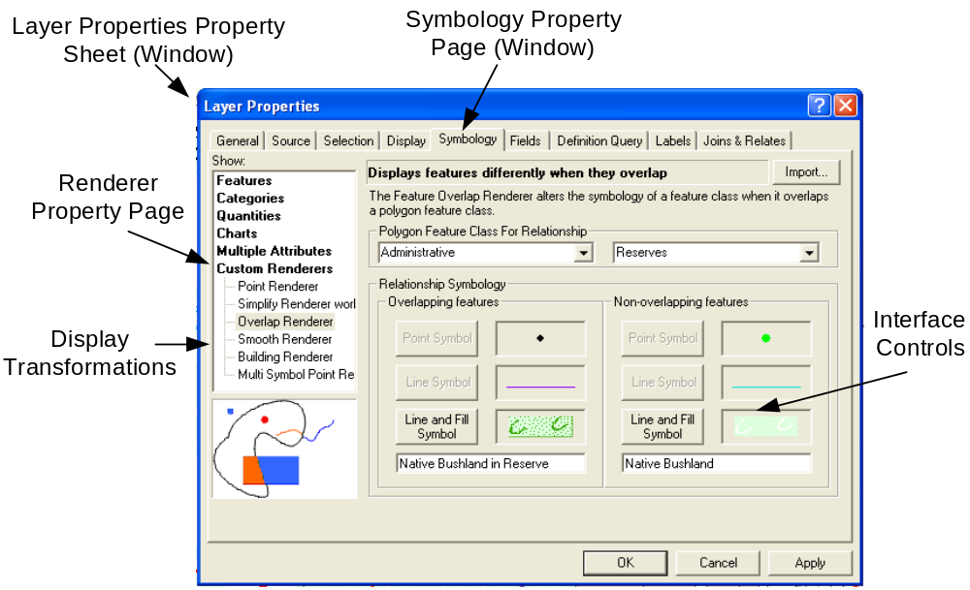
Figure 3 The display transformation user interface embedded within the ArcGIS Symbology Property Page
The draw method specifies a different piece of code for each spatial feature type. This means that when point, line and polygon object classes are transformed, the class member objects will behave differently in a spatial view depending on their spatial type. This methodology eliminates redundant coding and provides latitude when specifying product-specific behaviour.
The way the draw method is implemented is dependent on the specified display transformation code, which defines whether an object is simplified, collapsed or smoothed, etcetera. The transformation code is passed to a feature cursor, which iterates through each feature in turn, and the resulting transformation is written to the current display. The enumeration of features supports the application of thematic variability, as it is possible to apply different representations based on the thematic criteria of each object. This is illustrated in Figure 4 using the building object as an example. Building polygons are transformed (collapsed) and displayed as points according to the symbology defined by the user. This approach is different from the Multiple Representation Database (MRDB) (Cecconi, 2003) approach where alternate point and linear representations are stored in the database for map production a different scales.
Whilst display transformations are implemented in the same way, the transition of objects (in a class) from one state to another can be varied by applying different input parameters. This enables the application of cartographic representations to meet the objectives of theme and scale variability, as the transition of an object is completely controlled by the user

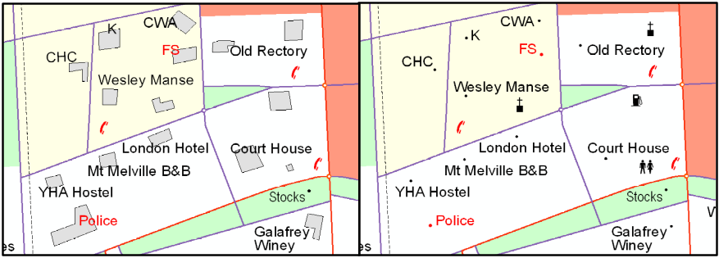
Figure 4 Conversion of buildings (polygons) to point representation

Map Production Case study
As part of the DSU research, a case study was examined to demonstrate the potential of DSU for producing a range of maps, which vary in theme and scale. The regional City of Albany on the south coast of Western Australia was chosen because the physical characteristics of the city and its environs contained considerable geographic variability. Data modelling could therefore, be evaluated extensively and theme variation applied and studied broadly. In addition, geographical data of appropriate precision were also available for the Albany area. These data were sufficiently extensive to enable a sample of medium and small scale maps to be evaluated. The Albany area is also well mapped, and a number of existing hard copy map products ranging in scale and theme were available.
These existing maps, produced using traditional techniques, were used to evaluate the database-sharing and spatial views approach in terms of presentation quality and production methodology. The map themes studied include road, tourist, topographic and electoral themes, and the map scales examined include 1: 10 000, 1:30000, 1:175 000, 1:250 000 and 1:1 000 000 respectively.
This study demonstrates the ability to produce maps from one high precision data source and indicates that the concept of separating real-world and product-specific behaviour has potential applicability to the development of a multipurpose geographic database for non-standard thematic map publishing. Specific cartographic requirements do not need to be structured into the database as they can be derived as required from the phenomenal view by way of cartographic transformation processes.
Results and Discussion
In terms of selection and elimination, the regional case study demonstrated that spatial queries can be formulated using the geographical database knowledge structure, in order to derive various cartographic information subsets. The only exception to this achievement is where the selection (or elimination) of features depends on their spatial proximity to other objects.
A higher level of complexity was observed when defining spatial queries for cartographic data subsets relating to buildings (locational phenomena) and roads (network phenomena) at a broad range of scales, than for discrete areas and continuous regions. This was partly due to the higher number of thematic variables, as these variables complicated the formulation of spatial queries. However, it was also due to the density and spatial distribution of map features at the mid scale range, as spatial queries were more difficult to implement when urban and rural areas had to be factored into the spatial query concurrently.
Display transformations were successful for generating theme- and scale-specific product multiplicities without impacting the underlying database. This means that no matter how an entity is represented in the database, it is possible to derive geometric, graphic and semantic multiplicities to suit product requirements. Because features are only manipulated for viewing and printing, the source data remains constant, and can therefore be accessed by multiple users. In addition, display transformations can be executed by the user without having to write complex code. This is an advantage over other implementation methods, such as custom object behaviours, class extensions and custom map layers, which require code modifications for each map variation.
The product enhancement process, enabled using a Displacement Display Transformation process, proved functional for displacing point feature representations; however linear features were not displaced satisfactorily, because network topology is not maintained and displacement can only be applied to a line in its entirety and not locally at the segment where the conflict occurs. There is a further need to incorporate topological operators into algorithms.
Annotation relationship classes, in conjunction with a map labelling engine, proved functional for implementing product-specific map feature labels. Map annotation content was effectively controlled using spatial queries and the appearance and placement of labels were successfully performed by stipulating conditions. More significantly, the case study demonstrated that generalised map labels, such as abbreviated terms or symbols, can be derived using label expressions in conjunction with the geographical knowledge-base. This avoids duplicate data storage and facilitates updating, as the need to store and maintain multiple attribute fields for map-specific annotation purposes, is eliminated.

Dynamic Spatial Updating Case Study
In order to evaluate both data management and product management, an experiment was performed to examine the spatial update cycle using the case study maps. The test environment was set as close as possible to realistic spatial data management and maintenance conditions that correspond to an industry benchmark for thematic map publishing.
The aim was to determine the percentage of update transactions successfully propagated to derived map products. In this way the effectiveness of DSU, based on a database-sharing and spatial views approach, could be compared to traditional cartographic revision processes where maps are stored as disconnected data sets.
To achieve this outcome, spatial updating was assessed in a systematic way by performing spatial updates to roads, buildings and parks in the multipurpose geographic database. Additions, semantic changes, modifications and deletions, were evaluated by examining their propagation to map products in terms of (a) selection and elimination in order to validate the application of rules that control map content; (b) cartographic representation in order to validate the application of product multiplicities at the map level thereby testing the behaviour of display transformation processes and annotation relationship classes with respect to updates performed in the database; and (c) map legibility and accuracy in order to assess whether additional cartographic enhancements are required to map features or annotation as a result of database updates.
The measure of achievement was based on whether updates were reflected according to the cartographic processes defined by the user. The degree of success of updating maps in real-time was measured by the degree of manual intervention required, where manual intervention is quantified by the number of update-propagation errors detected at the map level. This is because cartographic errors require manual resolution, and this introduces an overhead in data handling and increases the complexity of product management.
The performance of each spatial update transaction for DSU was based on accuracy. Scores were assigned for each evaluation stage. Where spatial updates were incorrect against the evaluation criteria a score of 1 was assigned. Those determined to be correct were not scored. Updates were validated in terms of both spatial representation and map annotation representation.
Results and Discussion
The results revealed that 87 percent of map updates can be propagated successfully to spatial views. This indicates that the amount of interactive updating required to revise non-standard thematic map products was reduced by 87 percent when compared to traditional processes.
This suggests that DSU has the potential to reduce costs associated with map revision as the processes relating to map content and cartographic representation were accurately and consistently applied across the case study maps. This indicates that (a) the spatial queries approach to selection and elimination has the potential to successfully control map content across a broad range of map scales and themes, and (b) display transformations and annotation rules, which govern feature and label representations, can potentially be applied as pseudo rule-bases to control cartographic symbology and generalised representations in accordance with scale- and theme-dependent map presentation requirements.
However, the consistency with which map products can be managed is compromised by a number of cartographic conflicts occurring as a result of update-propagation. Conflicts occurred at a rate of one in eight map updates (13 percent error). The majority (11 percent) of these errors occurred in relation to inadequate placement of labels in congested map areas. This problem, whilst endemic to contemporary automatic annotation systems, was more prevalent in this research, because the labelling engine used in the test-bed environment was not congruent with the display transformations approach. This is because label placement parameters and constraints in the test-bed environment are based on the geometric representation and location of objects in the database and not on the transformed generalised representation of features in spatial views. This suggests that for DSU to be effectively applied, more research into automatic map labelling systems is required.
In addition, 2 percent of the DSU error related to map illegibility, as cartographic displacement and enhanced map symbology caused map feature conflicts in spatial views. These conflicts mainly occurred when map scale varied considerably from database precision. This highlights that the current implementation of the Displacement Display Transformation is inadequate for DSU, as the map production process requires user interaction, and therefore, so too does the spatial updating process. More intelligence needs to be incorporated into the Displacement Display Transformation to achieve a fully automated displacement process.

Automatic Cartographic Conflict Detection CASE STUDY
The DSU experiment revealed that the DSU process is subject to 13 percent random update-propagation error. This means that a degree of uncertainty is introduced into the product management process. As a consequence, this research developed a cartographic validation process in order to promote consistency in the DSU process.
Cartographic conflicts (occurring in spatial views) are difficult to manage because the map producer is not privy to the information updates performed in the database, as these occur as a result of real-world changes implemented by the data custodian. Whilst a number of these conflicts are obvious, many are not, and this means that the conflict detection process may be subject to error.
Cartographic errors, and in particular cartographic conflicts, are a condition of the map-specific constraints unique to each map product. The type of conflicts occurring, and their prevalence, is a consequence of map theme, scale and graphic design considerations. This dependency means that the conflict detection process must be sensitive to the distinguishing characteristics of each map in order to have flexibility across a broad range of map products.
To meet the requirements of non-standard mapping applications, the following criteria for process development were formulated: (a) Conflict detection must be based on the cartographic representation of objects, not on the representation and location of objects in the underlying database; (b) the parameters for conflict detection must be applied consistently, according to map-specific constraints, and not be dependent on the preferences of multiple users; and (c) cartographic validation must be logistically simple to cater for all users.
In order to meet the above criteria, two approaches to conflict detection were examined. The first approach was based on detecting conflicts via software using relational operators, whilst the second examined spatial analysis concepts to detect conflicts by image comparison.
Of these alternatives, the software development approach proved to be the most difficult to implement, because the display transformation approach to map production does not create permanent graphic objects in a spatial view, but rather generates symbology on-the-fly as the display transformation passes through the record set of an object class. Validation on database objects is inappropriate because exaggerated road widths, collapsed buildings and displaced landmarks are not taken into consideration when determining conflicts. For maps produced using the display transformation approach, core program development is required to access the display parameters of map features for cartographic validation.
The need to perform conflict detection on the cartographic representation of objects led to the investigation of image-based spatial analysis concepts. A methodology was developed using a combination of image conversion techniques and spatial analysis tools available as software extensions to the test-bed environment. This methodology met the criteria for process development. Firstly, cartographic validation is based on the representation of features at the map level, and thus map-specific constraints are factored into the validation process. Secondly, the process is applicable to all map scales and themes and can therefore be executed by the user without the need to implement map-specific process variations or rule-based code.
The process for detecting map feature and label conflicts is implemented as a series of spatial analysis process-oriented steps. The aim of the methodology is to detect invalid overlapping map features by isolating a map feature class, such as buildings, so that it can be compared to other map features, such as roads, rivers and railways. The research develops a method for comparing map features and the organisation of comparison feature layers is applicable to range of map themes and scales. The validation process involves; (a) creation and reclassification of images ready for image comparison; (b) calculation of conflicts using overlay (spatial) analysis; and (c) amalgamation of detected conflicts detected to form one image in readiness for user investigation and resolution. For conflicts between features of the same type (same feature layer), a raster-edge extraction process was also incorporated.
This cartographic validation methodology was evaluated during the DSU experiment. The conflict detection process was performed after each iteration of spatial updates, in order to test whether or not cartographic errors could be detected without recourse to manual map interrogation techniques. The overall measures of effectiveness of the method for spatial data management and map revision was formulated in terms of the ability to; (a) maintain map products in a consistent and accurate manner; (b) manage the map revision process with minimal data handling; and (c) keep the update process logistically simple.
Results and Discussion
In the process of performing the DSU experiment 1,702 cartographic errors were recorded as a result of performing database additions, semantic changes, and modifications, in relation to buildings, roads and parks. Of these 1,702 DSU errors, 1,668 cartographic conflicts were successfully identified using the spatial analysis concepts developed. This result indicates that a 98 percent success rate can be achieved using the validation process to detect cartographic errors. The types of error successfully identified are shown in Figure 5.
However, the spatial analysis methodology is not fool proof. On three occasions, cartographic conflicts, between equivalent label types, were not detected using the raster-edge extraction process. This is because labels could completely overlap an adjacent label and therefore, no unique values were available for edge extraction. In addition, errors, relating to aspects of poor cartographic communication, were not detected on 18 occasions because the type of error was subjective and not characterised by a spatial conflict.

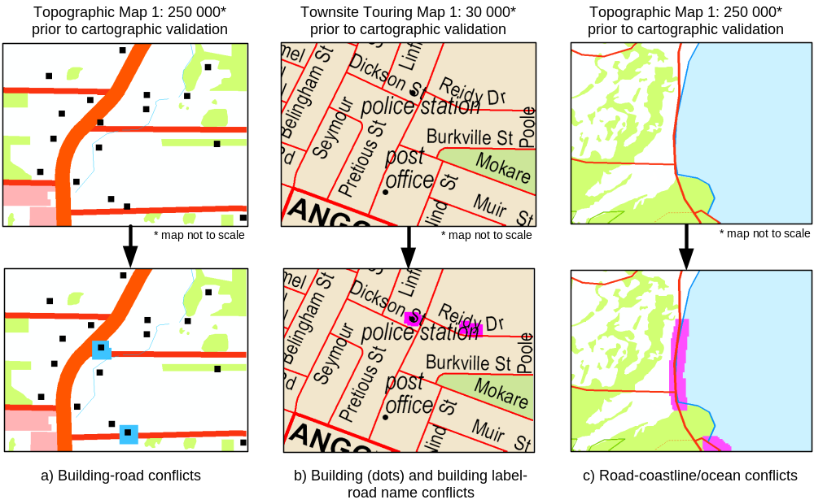
Figure 5 Cartographic errors successfully detected using spatial analysis concepts. Errors are highlighted by surrounding the error with a box of pixels

Conclusion
This paper develops the concept of dynamic spatial updating, which is formulated on a database-sharing and spatial views approach. This is a centralised approach to spatial data management and the case studies presented indicate that it has the potential to reduce the cost of map revision. This is because the amount of interactive updating required to revise non-standard thematic map products is reduced when compared to traditional methods.
The DSU process is based on modelling geographic phenomena according to their natural behavioural characteristics and not on their potential cartographic representations, as is the traditional approach. In this way the geographic database is not constrained to application-specific requirements, but rather permits the derivation of a variety of themes.
Map production is considered in the context of interactive cartographic processing. By implementing cartographic display transformation processes at the spatial view level using interactive techniques, this research has shown that the subjective and creative map design processes can be controlled by the user. This overcomes the limitation of automated mapping approaches, where users of geographic information often do not have autonomy to access the underlying database schema to implement rules necessary to regenerate their own enhanced versions of geographic data. However, further development is required to extend the DSU cartographic toolbox to include processes, such as typification, refinement, amalgamation, merge, and orientation to address complex generalisation requirements.
The DSU process is subject to random update-propagation error and therefore, a degree of uncertainty is introduced into the product management process. However, this research has demonstrated that by implementing a cartographic validation mechanism, based on spatial analysis concepts, map products can be managed consistently across a range of map scales and themes. The process has been tested as a component of the DSU experiment, and the results indicate that the majority of cartographic conflicts can be detected automatically. The success of the spatial analysis approach stems from the ability to incorporate map-specific validation constraints in the cartographic validation process.

References
Arnold, L.M. and Wright, G.L. (2005) Analysing Product-specific Behaviour to Support Process Dependent Updates in a Dynamic Spatial Updating Model, Transactions in GIS, Vol. 9, No. 3, pp. 397 - 419.
Badard, T. (1999) On the Automatic Retrieval of Updates in Geographic Databases Based on Geographic Data Matching Tools, Proceedings of 19th International Cartographic Conference and 11th General Assembly of ICA, Ottawa, Canada, August, pp. CD-ROM.
Bedard, V. and Bernier, E. (2002) Supporting Multiple Representations With Spatial Databases Views: Management and the Concept of <<Vuel>> [Online], Available: http://www.ikg.uni-hannover.de/isprs/list_of_presentations.html (21 January 2003).
Blanchfield, F.J. and Grubb, A. (2000) From Spatial Database to Paper Map for the 2001 Census Population and Housing, Proceedings of Mapping Sciences 2000, Mapping Sciences Institute, Australia, Sydney, Australia, December, pp. 17-34.
Cecconi, A. (2003) Integration of Cartographic Generalization and Multi-Scale Databases for Enhanced Web Mapping, PhD Thesis, University of Zurich, Zurich, 155 pp.
Claramunt, C. and Mainguenaud, M. (1996) Dynamic and Flexible Vision of a Spatial Database, Proceedings of 6th International Conference and Workshop on Database and Expert Sytems (DEXA '95), Omnipress, San Mateo, California, pp. 483-495.
Cooper, A. and Peled, A. (2001) Incremental Updating and Versioning, Proceedings of 20th International Cartographic Conference, Beijing, China, August, pp. 2804-2809.
Devogele, T., Trevisan, J. and Raynal, L. (1997) "Building a Multi-scale database with Scale-transistion Relationships", in: Advances in GIS II, (Proceedings of the 7th International Symposium on Spatial Data Handling), Kraak, M.-J. and Molenaar, M. (eds.), Taylor and Francis, London, UK, pp. 337-352.
Glover, E. and Mackaness, W. (1999) Dynamic Generalisation from Single Detailed Database to Support Web-based Interaction, Proceedings of 19th International Cartographic Conference, Ottawa, Canada, pp. 1175-1183.
Hampe, M., Anders, K. and Sester, M. (2003) MRDB Applications for Data Revision and Real-Time Generalisation, Proceedings of 21st International Cartographic Conference and 12th General Assembly, Durban, South Africa, 10-16 August, pp. 102-201.
Harrie, L. and Hellstrom, A.K. (1999) A Case Study of Propagating Updates Between Cartographic Data Sets, Proceedings of 19th International Cartographic Conference, Ottawa, Canada, August, p. on CD-ROM.

Howard, G., Pickering, R., Mole, D. and Woodsford, P. (2000) A National Topographic Database for the 21st Century - Paradigm Shifts in Business Process and Technology [Online], Available: http://www.laser-scan.com/papers/woodsford_pa_ica99.pdf (12 October 2001).
Joao, E.M. (1998) Causes and Consequences of Map Generalisation, Taylor & Francis Ltd, UK. 266 pp.
Kilpelainen, T. (2000) Maintenance of Multiple Representation Databases for Topographic Data, The Cartographic Journal, Vol. 37, No. 2, pp. 101-107.
Langran, G. (1993) Updating Map and Chart Series in an Automated Production Environment, Cartography and Geographic Information Systems, Vol. 20, No. 2, pp. 107-111.
Lanter, D. (1993) A Lineage Meta-Database Approach Toward Spatial Analytical Database Optimization, Cartography and Geographic Information Systems, Vol. 20, No. 2, pp. 112-121.
Millar, C. (1998) Arcview Automated Mapping, Proceedings of Mapping Sciences 1998, Mapping Sciences Institute, Australia, Fremantle, Australia, May 1998, pp. 472-479.
Timpf, S. and Couclelis, H. (1997) "Cartographic Objects in a Multi-scale Data Structure", in: Geographic Information Research: Bridging the Atlantic, Vol. 1, Craglia, M. (ed.), Taylor and Francis, pp. 22-234.
Uitermark, H. (2001) Ontology-based Geographic Data Set Integration, H.T. Uitermark, Deventer, The Netherlands. 139 pp.
Wijngaarden, F., Putten, J., Oosterom, P. and Uitermark, H. (1997) Map Integration - Update Propagation in a Multi-source Environment, Proceedings of 5th ACM International Workshop on Advances in Geographic Information Systems, Las Vegas, Nevada, pp. 71-76.
Williams, R.J. (1990) Phenomenological Structuring of Geographic Information, Proceedings of 8th Australian Cartographic Conference, Darwin, Northern Territory, Australia, April, pp. 185 - 195.
Worboys, M.F. (1995) GIS: A Computing Perspective, Taylor & Francis Ltd, London, p. 376.

